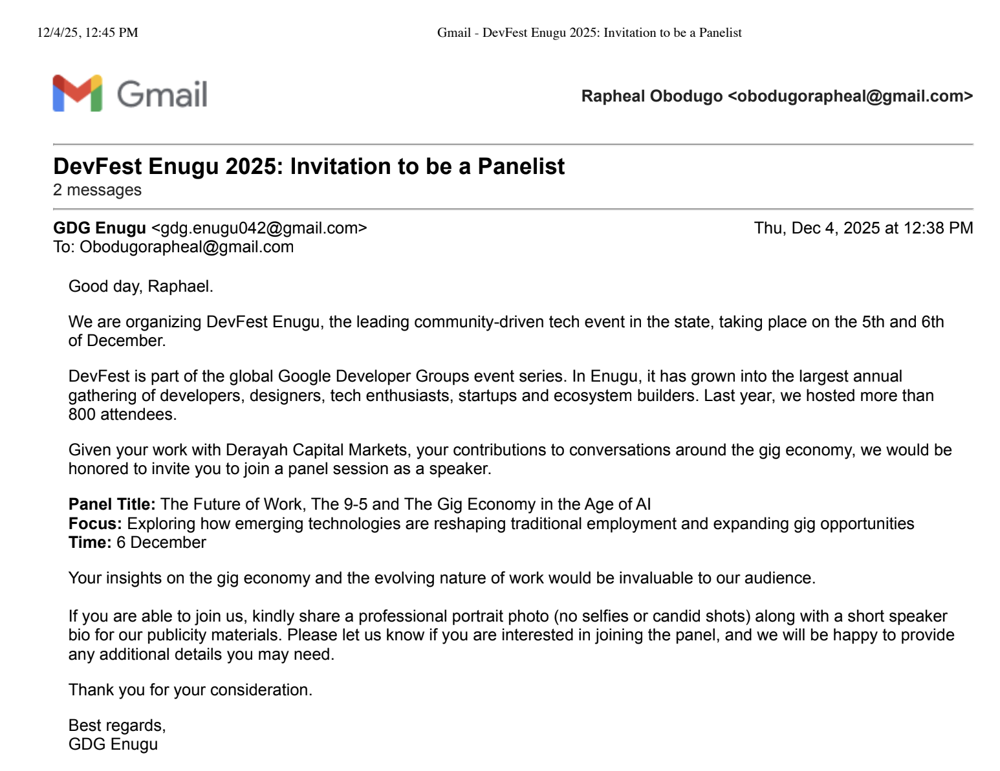

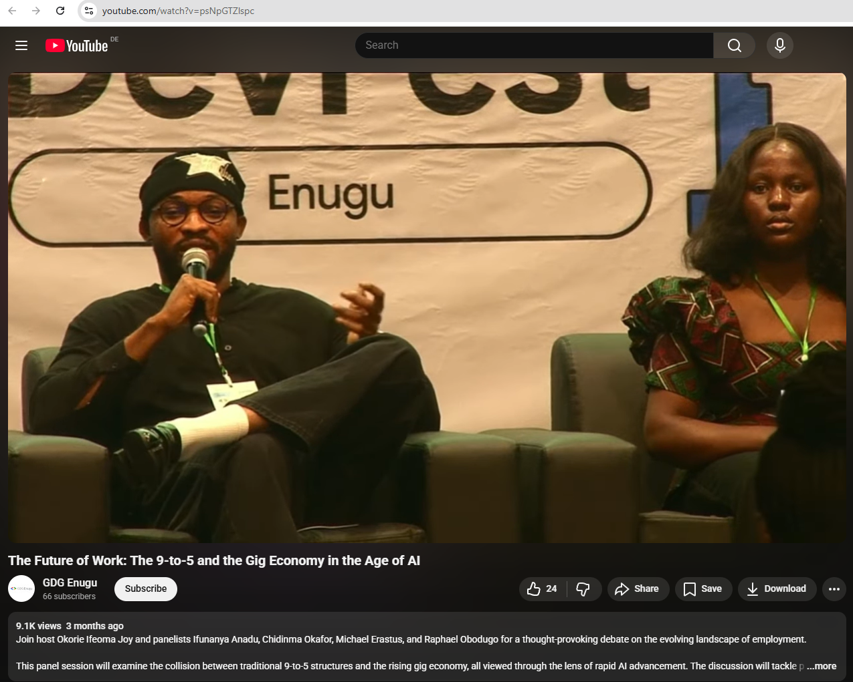

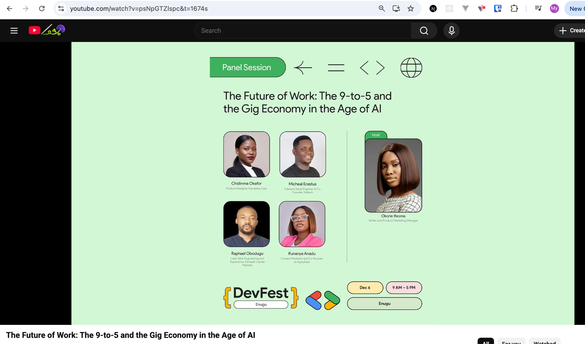
https://www.youtube.com/watch?v=psNpGTZlspc&t=1674s
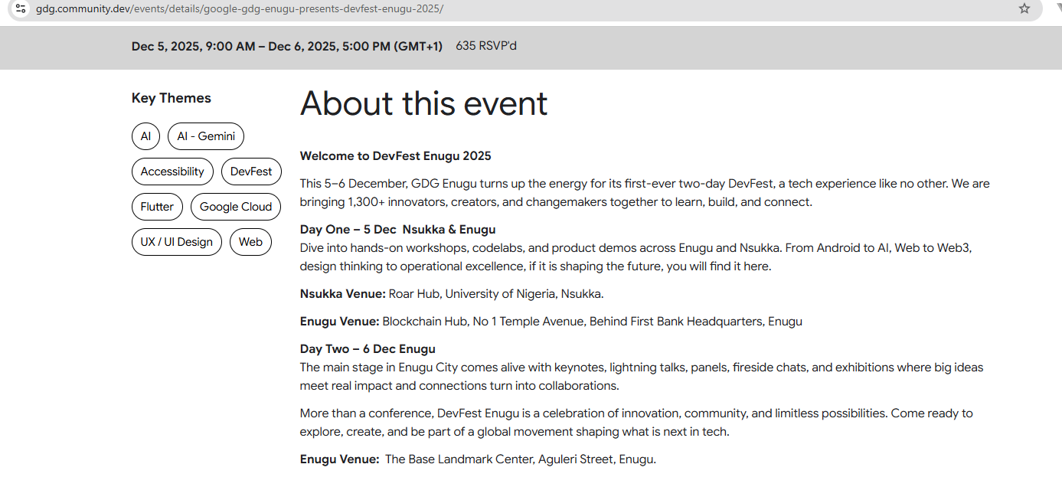
https://gdg.community.dev/events/details/google-gdg-enugu-presents-devfest-enugu-2025/

